The Battle of Neighborhoods

Coursera Capstone

10 April 2020

-

Abdullah

**Introduction:**

Due to the hard time finding new place to live in while changing your job this analysis will analyze the Neighborhoods of Toronto using Machine learning techniques to find the best suitable Neighborhoods for everyone providing a list of POI for each Neighborhoods matching them to the House finders’ profiles.

**Data:**

Couple of data used in this analysis:

1. Neighborhoods
2. Coordinates
3. POI
4. **Neighborhoods:**

Data used in this analysis is collected from different sourcing across the internet, the Neighborhoods includes some attribute such as

* + Postal code
  + Neighborhoods name
  + Borough

This data was collected from Wikipedia and processed using Python

Data was collected from [here](https://en.wikipedia.org/wiki/List_of_postal_codes_of_Canada:_M)

1. **Coordinates:**

Using Wikipedia data, we collected Latitude and Longitude using files from the internet and Google API to link each Neighborhoods to Latitude and Longitude

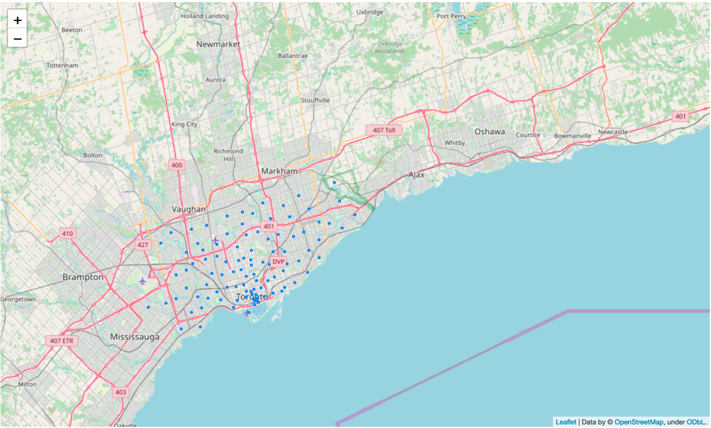

Map of Toronto Neighborhood after collection and processing

1. **POI:**

For each Coordinate linked toNeighborhoods we passed it to Foursquare API to retrieve POI for Radius of 1000 to each Coordinate to collect venues around that area.

So each Postal code should have the number of each one of listed category:

* Food
* Shops
* Parks outdoors
* Building
* Nightlife
* Travel
* Arts entertainment
* Education

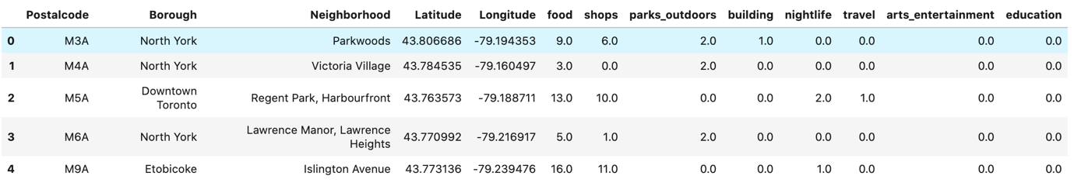

**Methodology:**

Using k-means clustering technique. to cluster each Neighborhoods based. On the numbers of each venue after determining the number of clusters using Elbow method:

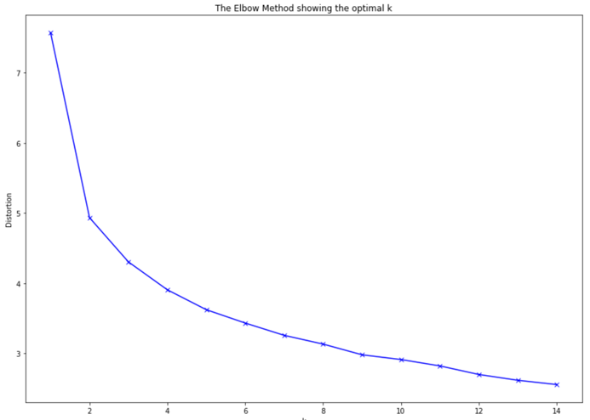

**Result:**

After applying the clustering method for each Neighborhoods

We can search the best preferred for each Neighborhoods boor linked to venues

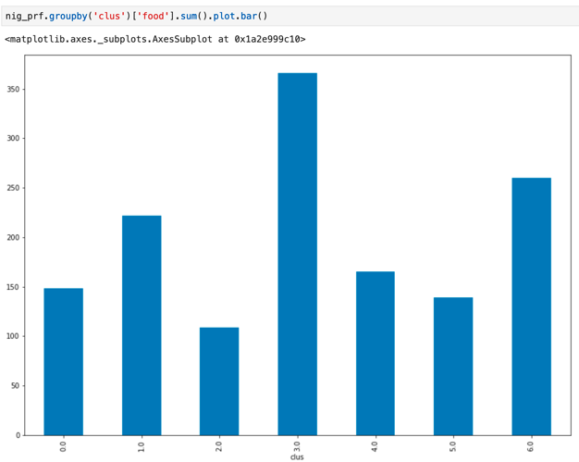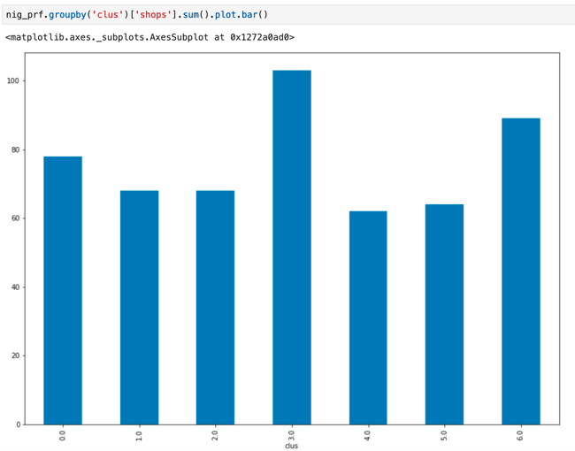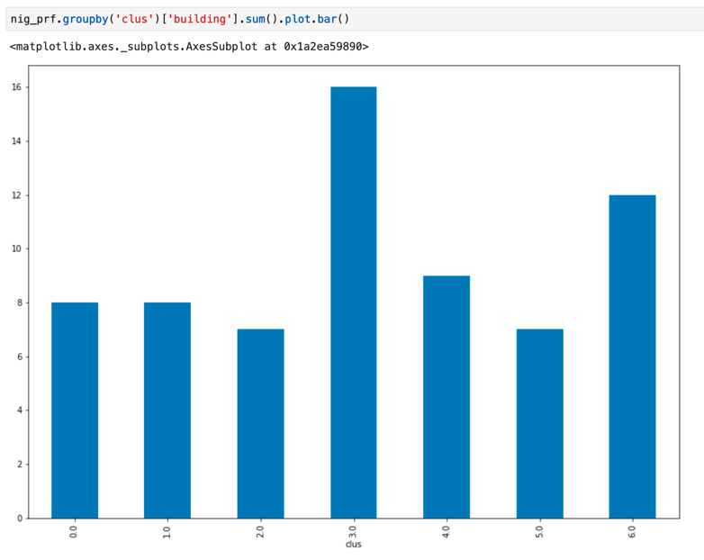

We can check number of clusters having venues for each category we search for.

**Discussion:**

Choosing your new Neighborhood depends in your interest and in this analysis you can check each venue and clustering them together to find you best match for your new home

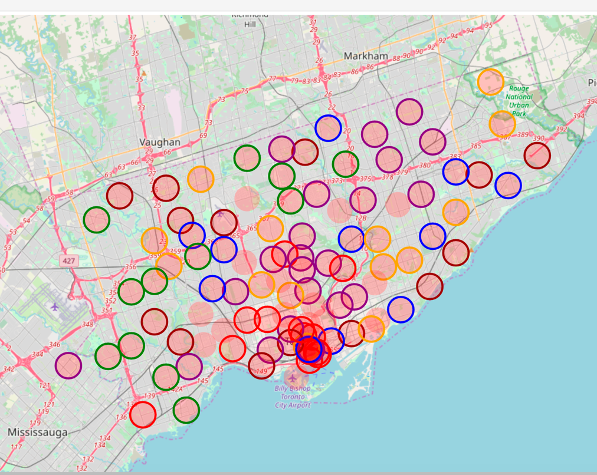

Using the result and plot it to the map you can user your Neighborhood.

**Conclusion:**

Data can make everything easier to people such simple analysis includes web wrangling API’s can find people preferredNeighborhood and make it easier to move to new jobs and homes.